CS 255 Business Requirements Document Template

Paloma Rodriguez

SNHU CS 255

June 12th, 2023 Project Two

UML Case Diagram: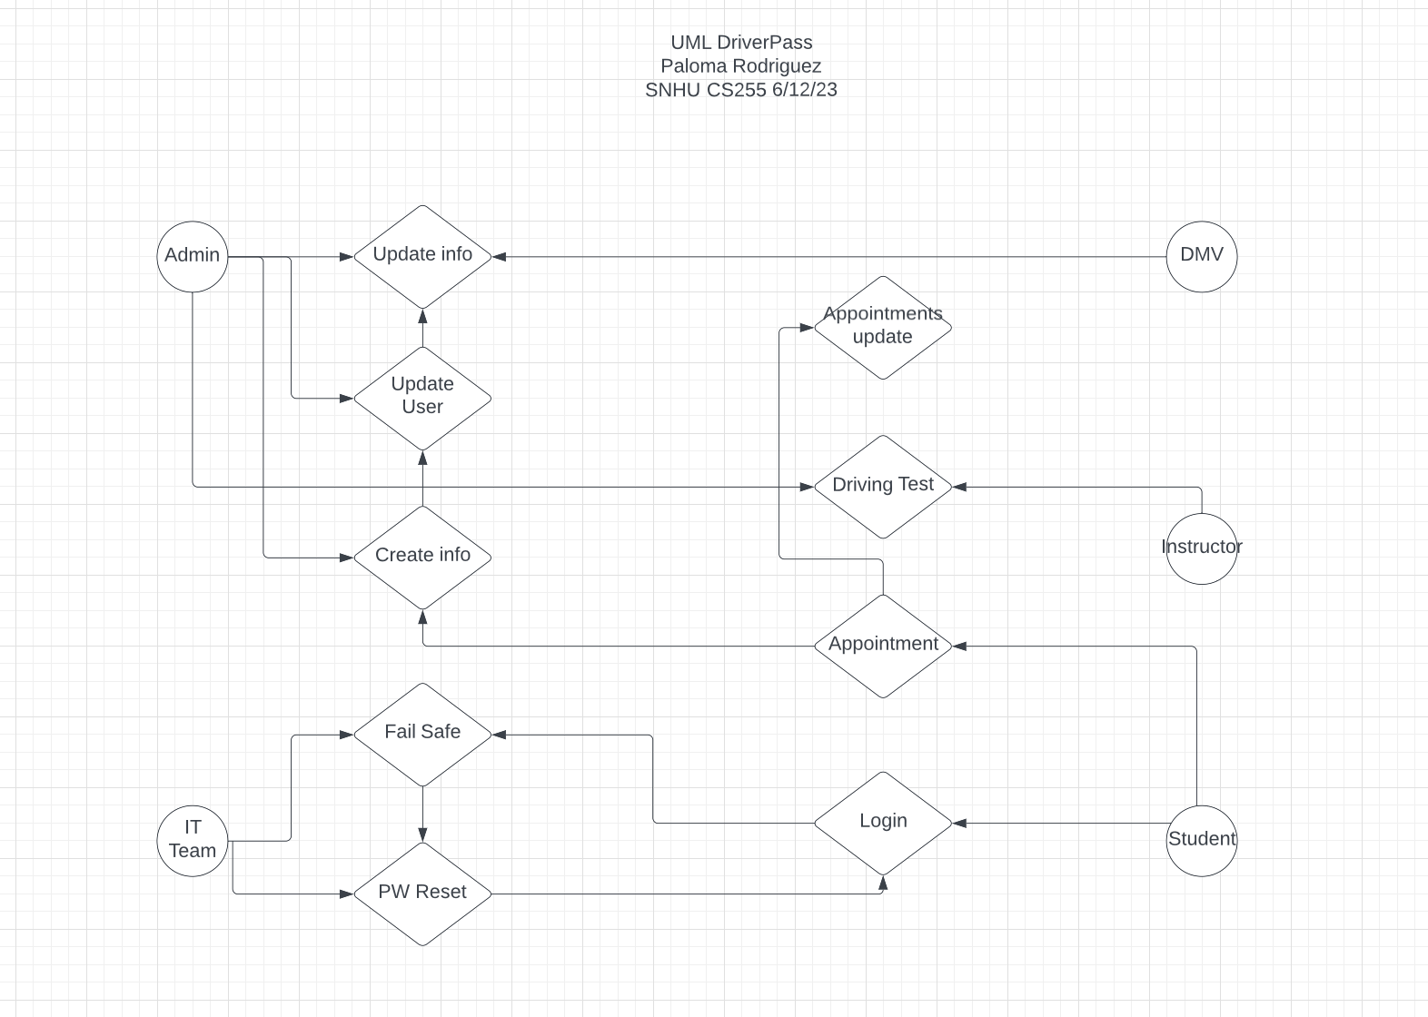

UML Activity Sequence Diagrams:

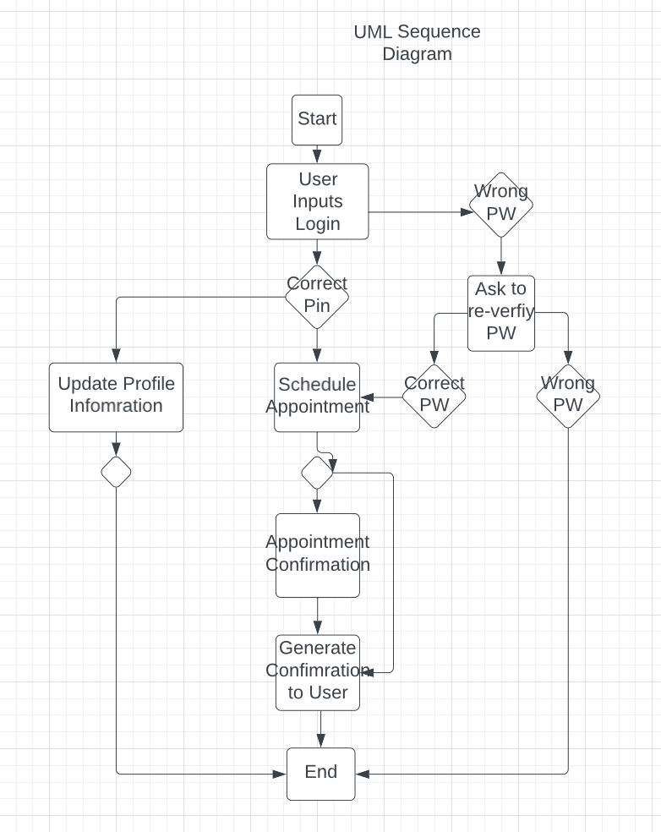

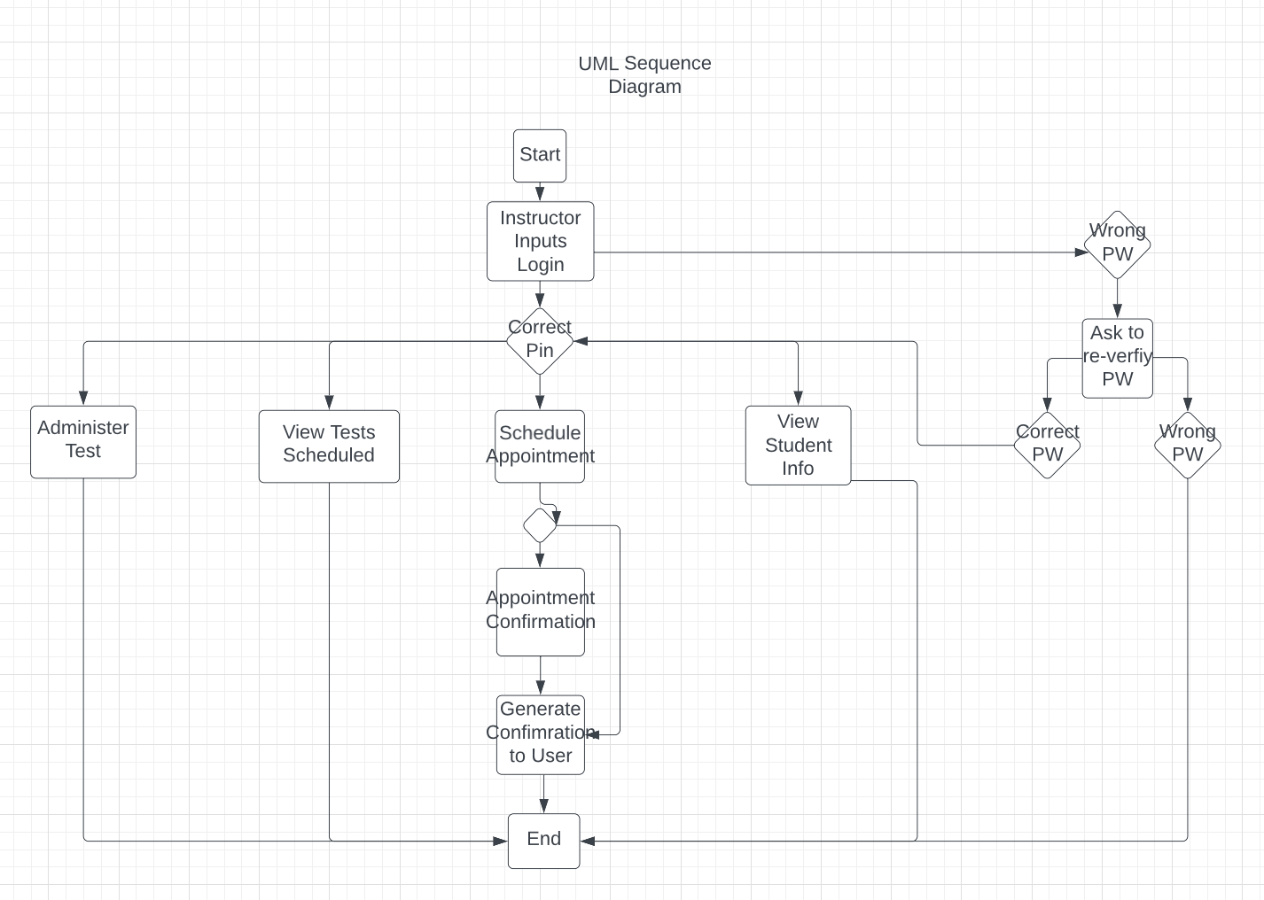

UML Class Diagram:

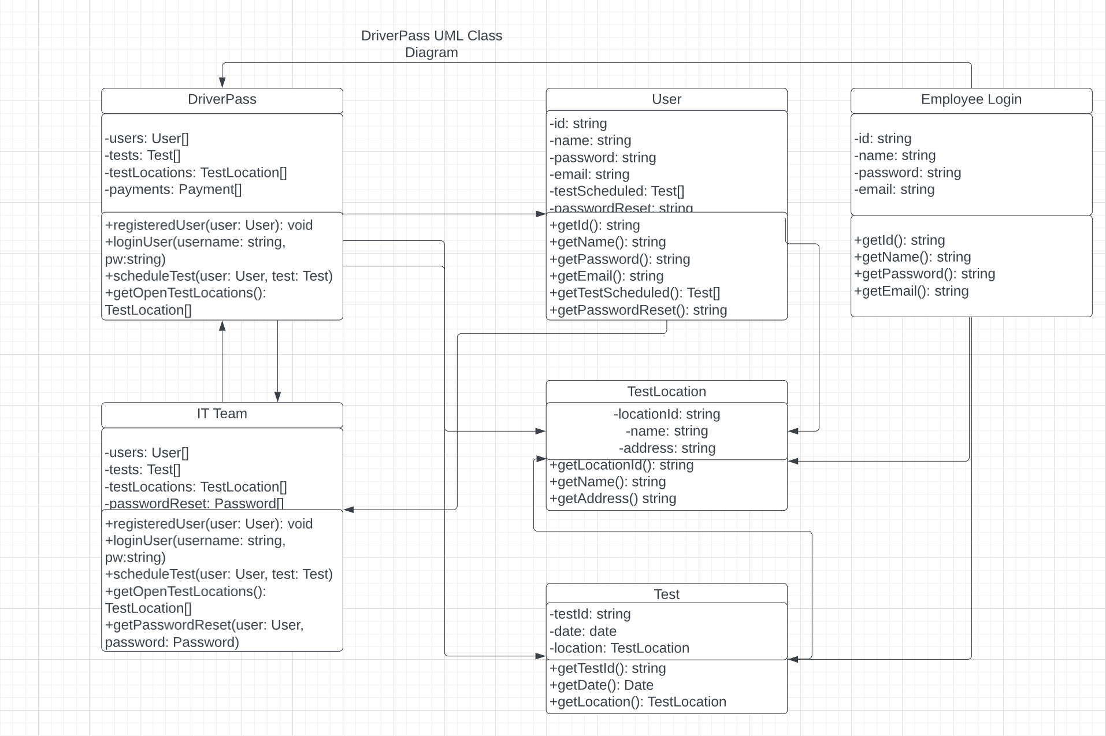

Technical Requirements:

The technical requirements of the DriverPass system include the necessary hardware, software, tools, and infrastructure to support the implementation of the system.

Hardware Requirements:

- The system will require servers to host the application, database, and other necessary components. The servers should have sufficient processing power, memory, and storage capacity to handle the anticipated user load.

- Network Infrastructure: A reliable network infrastructure is essential to ensure seamless communication between clients and servers.

Software Requirements:

- Operating System: The system may require an operating system (e.g., Windows, Linux) to run the servers and support the application and database software.

- Web Server: A web server will be necessary to serve the web application to users and handle HTTP requests and responses.

- Payment Integration: A secure and reliable payment gateway service to process payments made by users.

Tools and Development Environment:

- Integrated Development Environment (IDE): An IDE like IntelliJ, Eclipse, or Visual Studio can be used for development, debugging, and testing purposes.

- Security Tools: Tools such as SSL certificates, encryption libraries, and vulnerability scanners should be used to ensure secure data exchange and protect against potential threats.

Infrastructure Requirements:

- Scalability and Load Balancing: To handle scalability and load balancing is essential to ensure the system can handle a growing number of users and maintain optimal performance.

- Backup and Disaster Recovery: Regular backups of data and implementing disaster recovery measures are crucial to prevent data loss and ensure business continuity in the event of system failures.

These technical requirements are more so of an umbrella view of what will be need to successfully implement the DriverPass system to run seamlessly.